**Capability Maturity Model Integration** 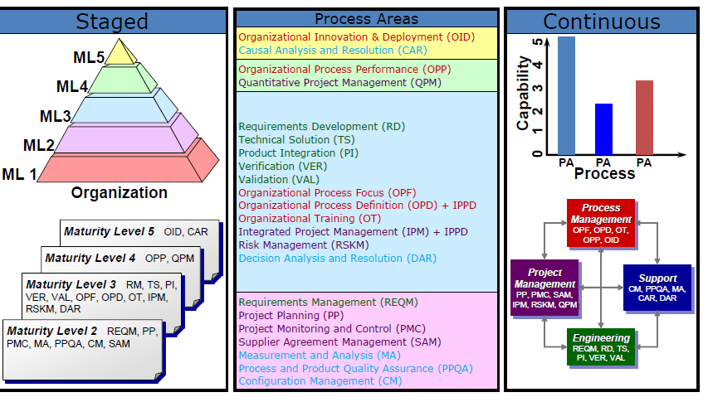

**GP 2.**

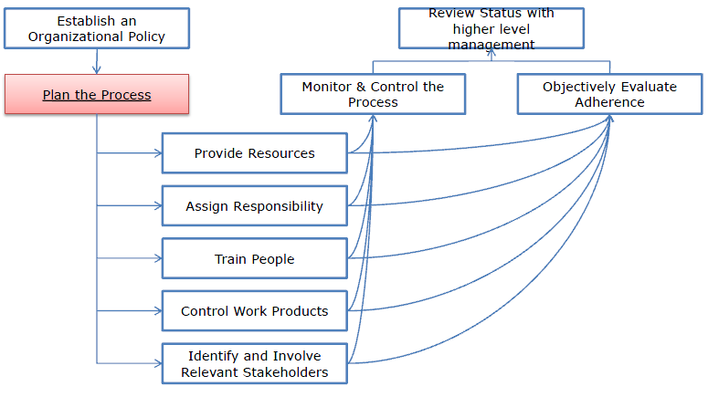**1. Establish Policy**

**2. Plan the Process**

**3. Provide Resources**

**4. Assign Responsibility**

**5. Train People**

**6. Manage Work Products**

**7. Identify and Involve Stakeholders**

**8. Monitor and Control the process**

|  |  |
| --- | --- |
| *Generic Goal* | *Progression of Processes* |
| GG 1 | Performed process |
| GG 2 | Managed process |
| GG 3 | Defined process |

**9. Objectively Evaluate Adherence**

**10.Review Status with Higher Level Management**

**GP 3.1 Establish a defined process**

**GP 3.2 Collect process related experience (improvement information)**

**Requirements Management**

Целта на RM е да управлява изискванията на продуктите на проекта и неговите компоненти и да установи несъответствията между тези изисквания и изискванията на плановете на проекта и продуктите.

**SG1:** Manage Requirements - Изискванията са управлявани и несъответствията с плановете на проекта и продуктите са установени.

SP 1.1 Obtain an Understanding of Requirements

SP 1.2 Obtain Commitment to Requirements

SP 1.3 Manage Requirements Changes

SP 1.4 Maintain Bidirectional Traceability of Requirements

SP 1.5 Identify Inconsistencies between project work and requirements

**GP 2.1: Establish an Organizational Policy**

Establish and maintain an organizational policy for planning

and performing the requirements management process.

**Elaboration for Requirements Management**

This policy establishes organizational expectations for

managing requirements and identifying inconsistencies

between the requirements and the project plans and work

products

**GP 2.2: Plan the process**

Establish and maintain the plan for performing the

requirements management process.

**Elaboration for Requirements Management**

This plan for performing the requirements management process can be

part of (or referenced by) the project plan as described in the Project

Planning process area.

**GP 2.3: Provide resources**

Provide adequate resources for performing the requirements

management process, developing the work products, and

providing the services of the process.

**Elaboration for Requirements Management**

Examples of resources provided include the following tools:

• Requirements tracking tools

• Traceability tools

**GP 2.4: Assign Responsibilities**

Assign responsibility and authority for performing the process,

developing the work products, and providing the services of

the requirements management process.

**GP 2.5: Train People**

Train the people performing or supporting the requirements

management process as needed.

**Elaboration for Requirements Management**

Examples of training topics include the following:

• Application domain

• Requirements definition, analysis, review, and management

• Requirements management tools

• Configuration management

• Negotiation and conflict resolution

**GP 2.6: Manage Work Products (Configurations)**

Place designated work products of the requirements

management process under appropriate levels of control.

**Elaboration for Requirements Management**

Examples of work products placed under control include the following:

• Requirements

• Requirements traceability matrix

**GP 2.7: Identify and Involve relevant Stakeholders**

Identify and involve the relevant stakeholders of the

requirements management process as planned.

**Elaboration for Requirements Management**

Select relevant stakeholders from customers, end users, developers,

producers, testers, suppliers, marketers, maintainers, disposal

personnel, and others who may be affected by, or may affect, the

product as well as the process.

Examples of activities for stakeholder involvement include the following:

• Resolving issues on the understanding of the requirements

• Assessing the impact of requirements changes

• Communicating the bidirectional traceability

• Identifying inconsistencies among project plans, work products, and

Requirements

**GP 2.8: Monitor and Control the process**

Monitor and control the requirements management process

against the plan for performing the process and take

appropriate corrective action.

**Elaboration for Requirements Management**

Examples of measures and work products used in monitoring and

controlling include

the following:

• Requirements volatility (percentage of requirements changed)

• Schedule for coordination of requirements

• Schedule for analysis of a proposed requirements change

**GP 2.9: Objectively Evaluate Adherence**

Objectively evaluate adherence of the requirements

management process against its process description,

standards, and procedures, and address noncompliance.

**GP 2.10: Review Status with Higher Level Management**

Review the activities, status, and results of the requirements

management process with higher level management and

resolve issues.

**Elaboration for Requirements Management**

Proposed changes to commitments to be made external to the

organization are reviewed with higher level management to ensure that

all commitments can be accomplished.

**REQM Practices:**

• Критериите за приемане на място?

• Изискванията отговарят на критериите?

• Is understanding reached and is it documented? How?

• Who are the relevant stake holders?

• Did they agree to requirements?

• Is the commitment documented? How?

• All requirements and their changes documented?

• Requirements change history and rationale documented?

• Are changes evaluated by affected stake holders?

• Bi-directional traceability among the requirements and the project

plans and work products maintained?

• Are the project plan/activities/work products reviewed to assess the

consistency with the (changed) requirements?

If inconsistencies have been are corrective actions initiated to solve them?

**Project Planning**

Целта на планиране на проекта (PP) е да установи и поддържа планове, които определят дейностите по проекта.

**SG1**Създаване на приблизителни оценки - Оценките на параметрите на планиране на проекта, са установени и поддържани.

**SG2:** Разработване на план на проекта - План на проекта е създадена и се поддържа като основа за управление на проекта.

**SG3:** Получаване на ангажименти в плана - Ангажименти към плана на проекта са установени и поддържани.

**SG1: Establish Estimates -** Estimates of project planning parameters are established and maintained.

**SG2: Develop a Project Plan -** A project plan is established and maintained as the basis for managing the project.

**SG3: Obtain Commitment to the Plan -** Commitments to the project plan are established and maintained.

**When Project Planning Is Not Done Well…**

Оценките на проекта атрибути са неточни.

Трудно е да се идентифицират отклонения от зле документирани планове.

Ресурсите не са налични / приложни когато е необходимо.

**Същността на PP:**

**• The Project Planning involves:**

o Създаване на плана на проекта

o Получаване ангажимент за плана

o Поддържане на плана

**• Планирането започва с изисквания, които определят продукт / проекта.**

**• Planning includes:**

o Оценка на атрибути на работните продукти и задачи

o Determining the resources needed

o Договаряне на ангажиментите

o Producing a schedule

o Identifying and analyzing project risks

**•** **плана на проекта, обикновено ще трябва да бъде ревизиран за решаване:**

o changes in requirements/commitments

o inaccurate estimates

o corrective actions

o process changes

**• “Project plan" - the overall plan for controlling the project.**

**Planning example:**

sampling Gantt Charts

Critical Path Analysis – CPA

PERT - Program Evaluation and Review

**Project Planning actions**

• Is there WBS/Project work packages based on project’s workproducts?

• Work products to be externally acquired/reused identified?

• Technical approach of work products determined?

(Development strategy – client-server/distributed, technologies)

• Duration, people, knowledge, inputs, outputs, infrastructure, etc. for the

project determined and how (what methods)?

• Resources required estimated?

• Project life cycle/phases determined?

• Project schedule and budget established?

• Risks that can affect to the project identified, documented and revised?

• Project data management issues addressed?

• Knowledge and skills requirements identified and addressed?

• Stakeholders identified, and project tasks related to them according their

expertise?

• Project plan established and commitments to it identified and documented?

• Is the project plan reviewed and actualized?

**Project Monitoring and Control**

The purpose of Project Monitoring and Control (PMC) is to provide an understanding of the project’s progress so that appropriate corrective actions can be taken when the project’s performance deviates significantly from the plan.

**SG 1**: Monitor Project Against Plan - Actual performance and progress of the project are monitored against the project plan.

**SG 2:** Manage Corrective Action to Closure - Corrective actions are managed to closure when the project's performance or results deviate significantly from the plan.

**When Project Monitoring and Control Is Not Done Well…**

Изгубено е много време в опити да се установи статуса на проекта.

Данни, необходими за вземането на управленски решения не са на разположение, когато е необходимо.

Коригиращи действия не е взето в началото, когато то е най-ефиктивно.

**The essence of PMC**

• PMC:

o monitoring activities

o communicating status

o taking corrective action

• Progress – at prescribed milestones (WBS/Schedule)

comparing to the planned:

o Actual work product and task attributes

o Effort, cost, and schedule

• When actual status deviates significantly –corrective

actions

• Corrective actions may include re-planning (PP)

**Sampling the Generic Practices**

**GP 2.8: Monitor and Control the Process:**

Monitor and control the project monitoring and

control process against the plan for performing the

process and take appropriate corrective action.

**Elaboration for Project Monitoring and Control:**

Examples of measures and work products used in

monitoring and controlling include the following:

o number of open and closed corrective actions

o schedule with status for monthly financial data

collection, analysis, and reporting

o number and types of reviews performed

o review schedule (planned versus actual and slipped

target dates)

o schedule for collection and analysis of monitoring data

**PMC Actions**

• Monitored:

o Progress against the schedule

o Cost, expended effort, staffing and training

o Actual resources usage

• Deviations documented?

• Internal and external commitments regularly reviewed?

• Risks status regularly reviewed/communicated to relevant stakeholder?

• Data management tasks regularly reviewed?

• Progress reviews:

o Task status communicated?

o Results documented?

• Milestone reviews conducted?

• Manage corrective actions to closure

o Issues analyzed and documented?

o Corrective actions tracked to closure?

o Results analyzed?

**Process and Product Quality Assurance**

The purpose of Process and Product Quality Assurance (PPQA) is to provide staff and management with objective insight into processes and associated work products. Целта на PPQA е да предоставят на персонала и ръководството обективно вникване в процесите и свързаните с тях работни продукти.

**SG 1:** Objectively Evaluate Processes and Work Products - Придържане към извършените процеси и свързаните с тях продукти прилагайки описание, стандарти и процедури на процесите се оценяват обективно.

**SG 2:** Provide Objective Insight - Noncompliance issues are objectively tracked and communicated, and resolution is ensured. Несъответващите проблеми са обективно проследени и съобщени и решението е осигурено

**SG 1:** Обективна оценка на процесите и дейностите;

**PPQA Practices**

• Are QA evaluations performed on processes/workproducts

according to predefined criteria?

• Performed processes adhere to the standards, process

descriptions and procedures?

• Non-compliance identified during the QA evaluations of

processes/work products?

• Lessons learned collected?

• Non-compliances resolved within the project/escalated?

• Relevant stakeholders aware of the results of the QA evaluations?

• Management reviews on non-compliances on periodic basis?

• Non-compliances tracked until closure?

• QA activities documented in sufficient detail?

• QA status and results known?

**How PPQA relates to Generic Practices? - Objectively Еvaluate Adherence**

**Measurement and Analysis**

The purpose of Measurement and Analysis (MA) is to develop and sustain a measurement capability used to support management information needs.

**SG 1:** Align Measurement and Analysis Activities - Measurement objectives and activities are aligned with identified information needs and objectives.

**SG 2:** Provide Measurement Results - Measurement results, which address identified information needs and objectives, are provided.

The essence of MA

• Specifying objectives of measurement/analysis - aligned with

information needs

• Specifying measures, data collection and storage mechanisms, analysis

techniques, and reporting and feedback mechanisms

• Implementing the collection, storage, analysis, and reporting of the data

• Providing objective results for making informed decisions, and taking

appropriate corrective actions

• Integration of measurement and analysis into the project supports:

o Planning and estimating

o Tracking actual performance against established plans and objectives

o Identifying and resolving process-related issues

o Providing a basis for incorporating measurement into additional processes in

the future

• The staff - from the projects or separate organization functions (e.g.,

QA).

• Initial focus - at the project level, MA might be useful for

organization/enterprise information needs.

• Project-specific data/results stored in a project-specific repository or

organization's measurement repository.

How MA relates to Generic

Practices? - Monitor & Control the Process

**Configuration Management**

The purpose of Configuration Management (CM) is to establish and maintain the integrity of work products using configuration identification, configuration control, configuration status accounting, and configuration audits.

**SG 1:** Establish Baselines - Baselines of identified work products are established.

**SG 2**: Track and Control Changes **-** Changes to the work products under configuration management are tracked and controlled.

**SG 3:** Establish Integrity - Integrity of baselines is established and maintained.

**What does Configuration Management Provide?**

State of components is known and there is confidence what and when can be released

When needed baselines can be recovered

Changes from baseline are identifiable

Past product releases can be rebuilt

Reasons for changes to plans are clear

**The essence of Configuration**

Management

CM Involves:

o Identifying the configuration of work products that compose the baselines

o Controlling changes to configuration items

o Building work products from the configuration management system

o Maintaining the integrity of baselines

o Providing status / configuration data to developers, end users, and customers

Work products placed under configuration management:

o products delivered to the customer

o internal work products

o acquired products

o tools

Configuration item may be:

o configuration component

o configuration unit

Baselines:

o provide a basis for evolution of configuration items

o added to the configuration management system as they are developed

o Changes to, are systematically controlled/monitored

This PA applies not only to projects, but also to organization work products (standards,

procedures, etc)

This PA is applicable to all work products that are placed under configuration

management.

**How CM relates to Generic Practices? - Control Work Products**

**Supplier Agreement Management**

The purpose of Supplier Agreement Management (SAM) is to manage the acquisition of products and services from suppliers.

**SG 1:** Establish Supplier Agreements - Agreements with the suppliers are established and maintained.

**SG 2:** Satisfy Supplier Agreements - Agreements with suppliers are satisfied by both the project and the supplier.

**GP 3.1 Establish a defined process**

**GP 3.2 Collect process related experience (improvement information)**

**Requirements Development**

The purpose of Requirements Development (RD) is to produce and analyze customer, product, and product component requirements.

**SG 1** Develop Customer Requirements - Stakeholder needs, expectations, constraints, and interfaces are collected and translated into customer requirements.

**SP 1.1 Elicit Needs** - Elicit stakeholder needs, expectations, constraints, and interfaces for all phases of the product lifecycle.

**SP 1.2 Transform** - Stakeholder Needs into Customer Requirements Transform stakeholder needs, expectations, constraints, and interfaces into customer requirements.

**SG 2** Develop Product Requirements - Customer requirements are refined and elaborated to develop product and product component requirements.

**SP 2.1 Establish Product and Product Component Requirements -** Establish and maintain product and product component requirements, which are based on the customer requirements.

**SP 2.2 Allocate Product -** Component Requirements Allocate the requirements for each product component.

**SP 2.3 Identify Interface** Requirements Identify interface requirements.

**SG 3** Analyze and Validate Requirements - The requirements are analyzed and validated, and a definition of required functionality is developed

**SP 3.1 Establish Operational Concepts and Scenarios -** Establish and maintain operational concepts and associated scenarios. SP 3.2 Establish a Definition of Required Functionality Establish and maintain a definition of required functionality.

**SP 3.3 Analyze Requirements -** Analyze requirements to ensure that they are necessary and sufficient.

**SP 3.4 Analyze Requirements to Achieve Balance** Analyze requirements to balance stakeholder needs and constraints.

**SP 3.5 Validate Requirements -** Validate requirements to ensure the resulting product will perform as intended in the user's environment.

.

**Importance of Requirements Development**

Present complete clear validated requirements understood by all parties.

Establish solid foundation for downstream activities.

**Benefits of Proper Requirements Development**

Development team and customer share the same

vision of what is to be developed, tested and

supported

Requirements are easily traceable to/from downstream work products

Acceptance by customer of downstream products is

easy & swift

Low risk of increased costs to meet customer needs

and expectations

**How Requirements Development interacts with other Process Areas?**

**Who does RD depend upon?**

o Requirements Management for managing

requirements

o Technical Solution for development of alternative

solutions and identification of product components

o Risk Management for identification and

management of requirements risks

**Who depends on RD?**

o Requirements Management takes requirements

from RD

o Product Integration takes interface requirements

o Verification & Validation

**Verification Versus Validation**

**Verification**

o Are you building the product right?

o That is, are you meeting the specified

requirements?

**Validation**

o Are you building the right product?

o That is, are you meeting the operational need?

**Verification**

Ensure that selected work products meet their specified requirements.

**SG 1:** Prepare for Verification - Preparation for verification is conducted.

**SG 2:** Perform Peer Reviews - Peer reviews are performed on selected work products.

**SG 3:** Verify Selected Work Products - Selected work products are verified against their specified requirements.

**When Verification Is Not Done Well**

There is disagreement among technical staff as to whether the different components meet the requirements.

The product being tested does not meet design requirements.

Product reliability suffers because defects are not detected or corrected prior to customer release.

Added rework occurs because defects that could have been caught early escape into later lifecycle phases.

**Validation**

Demonstrate that a product or product component fulfills its intended use when placed in its intended environment.

**SG 1:** Prepare for Validation - Preparation for validation is conducted.

**SG 2:** Validate Product or Product Components - The product or product components are validated to ensure that they are suitable for use in their intended operating environment.

**Sampling the Generic Practices**

**GP 2.3: Provide Resources**

Provide adequate resources for performing the validation process, developing the work products, and providing the services of the process.

**Elaboration for Validation**

Examples of other resources provided include the following tools:

o test-management tools

o test-case generators

o test-coverage analyzers

o simulators

o load, stress, and performance tools

**When Validation Is Not Done Well**

There are arguments among the technical staff as to what the user really wants.

The released product does not meet user expectations.

Customers do not pay for products that do not meet their needs.

End users refuse to use the product as delivered.

**Technical Solution**

Design, develop, and implement solutions to requirements. Solutions, designs, and implementations encompass products, product components, and product-related lifecycle processes either singly or in combinations as appropriate**.**

**SG 1:** Select Product Component Solutions - Product or product component solutions are selected from alternative solutions.

**SG 2**: Develop the Design - Product or product component designs are developed.

**SG 3:** Implement the Product Design - Product components, and associated support documentation, are implemented from their designs.

**When Technical Solution Is Not Done Well**

An ineffective solution is chosen.

Products may not meet technical

performance requirements or user needs.

Increased testing and rework is required to

resolve design issues.

The product may not be able to

accommodate technology upgrades and

future growth if the technical solution is

not well conceived.

**Risk Management (RSKM)**

Identify potential problems before they occur so that risk-handling activities can be planned and invoked as needed across the life of the product or project to mitigate adverse impacts on achieving objectives.

**SG 1**: Prepare for Risk Management - Preparation for risk management is conducted.

**SG 2:** Identify and Analyze Risks - Risks are identified and analyzed to determine their relative importance.

**SG 3**: Mitigate Risks - Risks are handled and mitigated, where appropriate, to reduce adverse impacts on achieving objectives.

**When Risk Management Is Not Done Well**

It is easy to ignore risks when they are not being tracked.

Risks that are known to project staff are often not known to management.

Repeated project failures due to unforeseen (but predictable) risks can cost you business.

**Sampling the Generic Practices**

**GP 2.10: Review Status with Higher Level Management**

Review the activities, status, and results of the risk management process with higher level management and

resolve issues.

**Elaboration for Risk Management**

Reviews of the project risk status are held on a periodic and event-driven basis with appropriate levels of

management, to provide visibility into the potential for project risk exposure and appropriate corrective action.

Typically, these reviews will include a summary of the most critical risks, key risk parameters (such as

likelihood and consequence of these risks), and the status of risk mitigation efforts.

**Higher Levels of CMMI Maturity Lead to Lower Risk**

**Level 2 expects a start at risk management**

• Project Planning SP 2.2 Identify and analyze project risks

**Level 3 provides the Risk Management Process Area**

• Establishes a defined process with additional breadth of subject and organizational coverage

• Risk sources and categories used to more effectively identify and handle risks.

**Level 4 quantitatively defines the impact of risk on project success**

• Process volatility a major source of risk

• Data allows better prioritization and control of risks

**Level 5** activities produce action proposals which often address sources of high risk