CCNA 1 Chapter 9 V4.0 Answers

1.
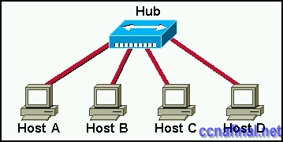
In the graphic, Host A has reached 50% completion in sending a 1 KB Ethernet frame to Host D when Host B wishes to transmit its own frame to Host C. What must Host B do?
Host B can transmit immediately since it is connected on its own cable segment.
Host B must wait to receive a CSMA transmission from the hub, to signal its turn.
Host B must send a request signal to Host A by transmitting an interframe gap.
Host B must wait until it is certain that Host A has completed sending its frame.
2. Ethernet operates at which layers of the OSI model? (Choose two.)
Network layer
Transport layer
Physical layer
Application layer
Session layer
Data-link layer
3. Which of the following describe interframe spacing? (Choose two.)
the minimum interval, measured in bit-times, that any station must wait before sending another frame
the maximum interval, measured in bit-times, that any station must wait before sending another frame
the 96-bit payload padding inserted into a frame to achieve a legal frame size
the 96-bit frame padding transmitted between frames to achieve proper synchronization
the time allowed for slow stations to process a frame and prepare for the next frame
the maximum interval within which a station must send another frame to avoid being considered unreachable
4. What three primary functions does data link layer encapsulation provide? (Choose three.)
addressing
error detection
frame delimiting
port identification
path determination
IP address resolution
5. When a collision occurs in a network using CSMA/CD, how do hosts with data to transmit respond after the backoff period has expired?
* The hosts return to a listen-before-transmit mode.
The hosts creating the collision have priority to send data.
The hosts creating the collision retransmit the last 16 frames.
The hosts extend their delay period to allow for rapid transmission.
6. What are three functions of the upper data link sublayer in the OSI model? (Choose three.)
recognizes streams of bits
identifies the network layer protocol
makes the connection with the upper layers
identifies the source and destination applications
insulates network layer protocols from changes in physical equipment
determines the source of a transmission when multiple devices are transmitting
7. What does the IEEE 802.2 standard represent in Ethernet technologies?
MAC sublayer
Physical layer
Logical Link
Control sublayer
Network layer
8. Why do hosts on an Ethernet segment that experience a collision use a random delay before attempting to transmit a frame?
A random delay is used to ensure a collision-free link.
A random delay value for each device is assigned by the manufacturer.
A standard delay value could not be agreed upon among networking device vendors.
* A random delay helps prevent the stations from experiencing another collision during the transmission.
9.
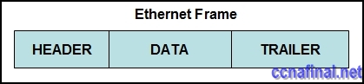
Refer to the exhibit. Which option correctly identifies content that the frame data field may contain?
preamble and stop frame
network layer packet
physical addressing
FCS and SoF
10. Host A has an IP address of 172.16.225.93 and a mask of 255.255.248.0. Host A needs to communicate with a new host whose IP is 172.16.231.78. Host A performs the ANDing operation on the destination address. What two things will occur? (Choose two.)
Host A will change the destination IP to the IP of the nearest router and forward the packet.
Host A will broadcast an ARP request for the MAC of its default gateway.
A result of 172.16.225.0 will be obtained.
Host A will broadcast an ARP request for the MAC of the destination host.
A result of 172.16.224.0 will be obtained.
A result of 172.16.225.255 will be obtained.
11. Which of the following is a drawback of the CSMA/CD access method?
Collisions can decrease network performance.
It is more complex than non-deterministic protocols.
Deterministic media access protocols slow network performance.
CSMA/CD LAN technologies are only available at slower speeds than other LAN technologies.
12. Ethernet operates at which layer of the TCP/IP network model?
application
physical
transport
internet
data link
network access
13. What is the primary purpose of ARP?
translate URLs to IP addresses
resolve IPv4 addresses to MAC addresses
provide dynamic IP configuration to network devices
convert internal private addresses to external public addresses
14.
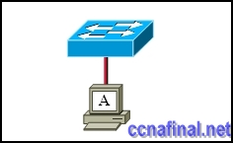
Refer to the exhibit. The switch and workstation are administratively configured for full-duplex operation. Which statement accurately reflects the operation of this link?
No collisions will occur on this link.
Only one of the devices can transmit at a time.
The switch will have priority for transmitting data.
The devices will default back to half duplex if excessive collisions occur.
15.
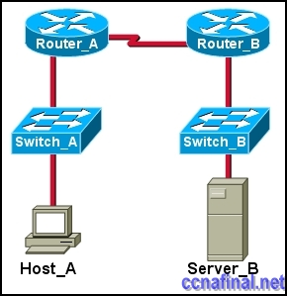
Refer to the exhibit. Host_A is attempting to contact Server_B. Which statements correctly describe the addressing Host_A will generate in the process? (Choose two.)
A packet with the destination IP of Router_B.
A frame with the destination MAC address of Switch_A.
A packet with the destination IP of Router_A.
A frame with the destination MAC address of Router_A.
A packet with the destination IP of Server_B.
A frame with the destination MAC address of Server_B.
16. Which statements correctly describe MAC addresses? (Choose three.)
dynamically assigned
copied into RAM during system startup
layer 3 address
contains a 3 byte OUI
6 bytes long
32 bits long
17. Which two features make switches preferable to hubs in Ethernet-based networks? (Choose two.)
reduction in cross-talk
minimizing of collisions
support for UTP cabling
division into broadcast domains
increase in the throughput of communications
18. What are the two most commonly used media types in Ethernet networks today? (Choose two.)
coaxial thicknet
copper UTP
coaxial thinnet
optical fiber
shielded twisted pair
19. Convert the binary number 10111010 into its hexadecimal equivalent. Select the correct answer from the list below.
85
90
BA
A1
B3
1C
20. After an Ethernet collision, when the backoff algorithm is invoked, which device has priority to transmit data?
the device involved in the collision with the lowest MAC address
the device involved in the collision with the lowest IP address
any device in the collision domain whose backoff timer expires first
those that began transmitting at the same time
21.
Refer to the exhibit. What command was executed on a host computer to produce the results shown?
route PRINT
arp –a
arp –d
netstat
telnet

Taged:
network fundamentals chapter nine exam

Related Posts
- CCNA 1 Chapter 11 V4.0 Answers
- CCNA 1 Chapter 10 V4.0 Answers
- CCNA 1 Chapter 8 V4.0 Answers
- CCNA 1 Chapter 7 V4.0 Answers
- CCNA 1 Chapter 6 V4.0 Answers
- CCNA 1 Chapter 5 V4.0 Answers
- CCNA 1 Chapter 2 V4.0 Answers 100% updated 2011
- CCNA 1 Chapter 1 V4.0 Answers Updated 2011 100%
Tags: CCNA 1, ccna 1 2011, CCNA 1 Chapter 1, ccna 1 chapter 1 100%, ccna 1 chapter 1 2011, CCNA 1 Chapter 1 Answers, CCNA 1 Chapter 1 V4.0 Answers, ccna 1 module 1
← CCNA 4 Final Exam Answers (B) CCNA 1 Chapter 2 V4.0 Answers 100% updated 2011 →

Leave a Reply

