CCNA 1 Chapter 3 V4.0 Answers 100 Updated 2011
Updated 2011 100%
www.ccnafinal.net
1. What application layer protocol is commonly used to support for file transfers between a client and a server?
HTML
HTTP
FTP
Telnet
2. What are two forms of application layer software? (Choose two.)
applications
dialogs
requests
services
syntax
3. A network administrator is designing a network for a new branch office of twenty-five users. What are the advantages of using a client-server model? (Choose two.)
centralized administration
does not require specialized software
security is easier to enforce
lower cost implementation
provides a single point of failure
4. What is the purpose of resource records in DNS?
temporarily holds resolved entries
used by the server to resolve names
sent by the client to during a query
passes authentication information between the server and client
5. What is the automated service that matches resource names with the required IP address?
HTTP
SSH
FQDN
DNS
Telnet
SMTP
6. What three protocols operate at the Application layer of the OSI model? (Choose three.)
ARP
DNS
PPP
SMTP
POP
ICMP
7. What are three properties of peer-to-peer applications? (Choose three.)
acts as both a client and server within the same communication.
requires centralized account administration.
hybrid mode includes a centralized directory of files.
can be used in client-server networks.
requires a direct physical connection between devices.
centralized authentication is required.
8. Which application layer protocols correctly match a corresponding function? (Choose two.)
DNS dynamically allocates IP addresses to hosts
HTTP transfers data from a web server to a client
POP delivers email from the client to the server email server
SMTP supports file sharing
Telnet provides a virtual connection for remote access
9. Which email components are used to forward mail between servers? (Choose two.)
MDA
IMAP
MTA
POP
SMTP
MUA
10. As compared to SSH, what is the primary disadvantage of telnet?
not widely available
does not support encryption
consumes more network bandwidth
does not support authentication
11. Which statements are correct concerning the role of the MTA in handling email? (Choose three.)
routes email to the MDA on other servers
receives email from the client’s MUA
receives email via the POP3 protocol
passes email to the MDA for final delivery
uses SMTP to route email between servers
delivers email to clients via the POP3 protocol
12. Which two protocols are used to control the transfer of web resources from a web server to a client browser? (Choose two.)
ASP
FTP
HTML
HTTP
HTTPS
IP
13. A small home network has been installed to interconnect three computers together for gaming and file sharing. What two properties represent this network type? (Choose two.)
User accounts are centralized.
Security is difficult to enforce.
Specialized operating system software is required.
File permissions are controlled by a single computer.
A computer that responds to a file sharing request is functioning as a server.
14. Which layer of the OSI model supplies services that allow user to interface with the network?
physical
session
network
presentation
application
transport
15.
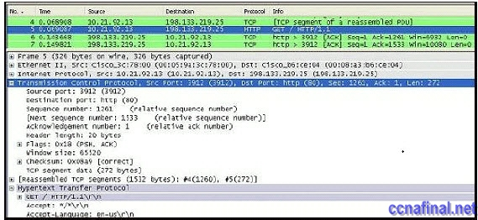
ccna 1 chapter 3 answers 100%
Refer to the exhibit. What is the destination port for the communication that is represented on line 5?
80
1261
15533
3912
65520
16. What are two characteristics of peer-to-peer networks? (Choose two.)
scalable
one way data flow
decentralized resources
centralized user accounts
resource sharing without a dedicated server
17. What application layer protocol describes the services that are used for file sharing in Microsoft networks?
DHCP
DNS
SMB
SMTP
Telnet
18. What are two characteristics of clients in data networks? (Choose two.)
use daemons
initiate data exchanges
are repositories of data
may upload data to servers
listen for requests from servers
19. What is the role of the OSI application layer?
provides segmentation of data
provides encryption and conversion of data
provides the interface between the applications on either end of the network
provides control of all the data flowing between the source and destination devices
20. How does the application layer on a server usually process multiple client request for services?
ceases all connections to the service
denies multiple connections to a single daemon
suspends the current connection to allow the new connection
uses support from lower layer functions to distinguish between connections to the service

Taged:
ccna 3 version 4 0 2011,chapter 3 ccna 2011

Related Posts
- CCNA 1 Final Exam V4.0 Answers
- CCNA 1 Chapter 4 V4.0 Answers 100% updated 2011
- CCNA 1 Chapter 2 V4.0 Answers 100% updated 2011
- CCNA 1 Chapter 1 V4.0 Answers Updated 2011 100%
- CCNA 1 Final Exam Answers
Tags: CCNA 1, CCNA 1 Final, CCNA 1 Final Exam, CCNA 1 Final Exam Answers, CCNA 1 final exam answers 2010, CCNA 1 final exam answers 2011, CCNA 1 Final Exam Questions and Answers 2010, ccna final exam answers 4.0, ccna1 final exam, CCNA4 Final
← CCNA 4 Final answers (100% Guaranteed – Updated Dec 2010) CCNA 2 Final Exam Answers →

2 Responses to CCNA 1 Final Exam Answers

