CCNA 1 Chapter 10 V4.0 Answers
1.
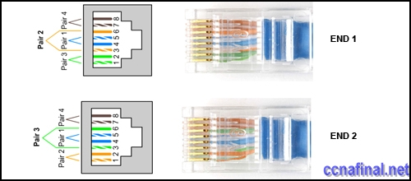
Refer to the exhibit. A student working in the lab selects a cable that is wired as shown. Which connection types can successfully be made with this cable? (Choose two.)
connecting a PC to a router’s console port
connecting two routers together via their fast ethernet ports
connecting two switches together at gigabit speeds
connecting a PC to a switch at Gigabit Ethernet speeds
connecting two devices with the same interface type at Fast Ethernet speeds
2. Which three statements are true about the role of routers in the network? (Choose three.)
They propagate broadcasts.
They enlarge collision domains.
They segment broadcast domains.
They interconnect different network technologies.
Each router interface requires a separate network or subnet.
They maintain a common frame format between LAN and WAN interfaces.
3.
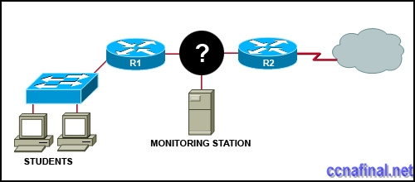
Refer to the exhibit. A network administrator has decided to use packet capture software to evaluate all traffic from the student subnet on the way to the Internet. To ensure that all packets are captured, what network device should be used to connect the monitoring station to the network between R1 and R2?
router
hub
switch
wireless access point
4. A network administrator is required to use media in the network that can run up to 100 meters in cable length without using repeaters. The chosen media must be inexpensive and easily installed. The installation will be in a pre-existing building with limited cabling space. Which type of media would best meet these requirements?
STP
UTP
coaxial
single-mode fiber
multimode fiber
5.
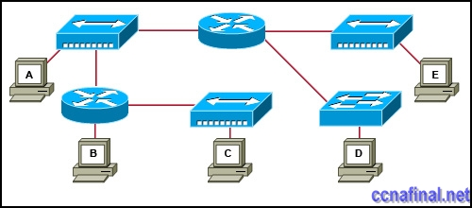
Refer to the exhibit. Which three statements are true about the exhibited topology? (Choose three.)
Hosts B and C are in the same subnet.
Five broadcast domains are present.
Host B is using a crossover cable to connect to the router.
Four broadcast domains are present.
Five networks are shown.
Host B is using a rollover cable to connect to the router.
6. Which three types of connectors are commonly associated with Cisco’s V.35 serial cables? (Choose three.)
RJ 11
DB 60
Winchester 15 pin
DB 9
smart serial
RJ 45
7. How many host addresses may be assigned on each subnetwork when using the 130.68.0.0 network address with a subnet mask of 255.255.248.0?
30
256
2046
2048
4094
4096
8.
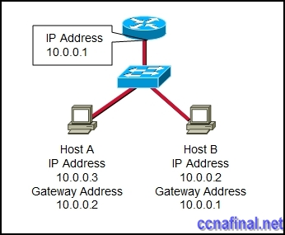
Refer to the exhibit. Based on the IP configuration shown, what would be the result of Host A and Host B attempting to communicate outside the network segment?
both host A and B would be successful
host A would be successful, host B would fail
host B would be successful, host A would fail
both Host A and B would fail
9.
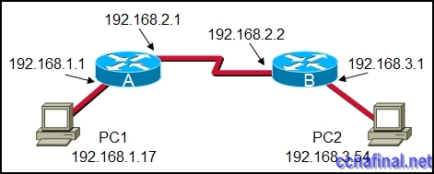
Refer to the exhibit. What destination IP address will PC1 place in the header for a packet destined for PC2?
192.168.1.1
192.168.2.1
192.168.2.2
192.168.3.1
192.168.3.54
10.
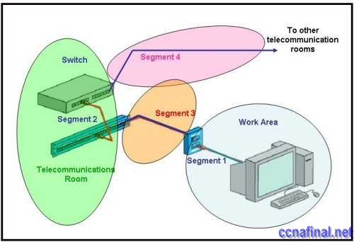
Refer to the exhibit. Which three statements identify the type of cabling that would be used in the segments that are shown? (Choose three.)
Segment 1 uses backbone cabling.
Segment 1 uses a patch cable.
Segment 3 uses patch cabling.
Segment 3 uses vertical cabling.
Segment 3 uses horizontal cabling.
Segment 4 uses vertical cabling.
11. A company is planning to subnet its network for a maximum of 27 hosts. Which subnet mask would provide the needed hosts and leave the fewest unused addresses in each subnet?
255.255.255.0
255.255.255.192
**255.255.255.224
255.255.255.240
255.255.255.248
12.
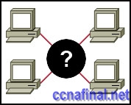
Refer to the exhibit. A student is setting up a home network primarily used for extensive file transfers, streaming video, and gaming. Which network device is best suited to these types of activities in the topology shown?
wireless access point
router
hub
switch
13.
Refer to the exhibit. How many subnets are required to support the network that is shown?
2
3
4
5
14. What does the term “attenuation” mean in data communication?
loss of signal strength as distance increases
time for a signal to reach its destination
leakage of signals from one cable pair to another
strengthening of a signal by a networking device
15. To establish a console connection from a computer to a Cisco router, which cable wiring option would be used?
crossover cable
straight through cable
rollover cable
V.35 cable
16. What makes fiber preferable to copper cabling for interconnecting buildings? (Choose three.)
greater distances per cable run
lower installation cost
limited susceptibility to EMI/RFI
durable connections
greater bandwidth potential
easily terminated
17.
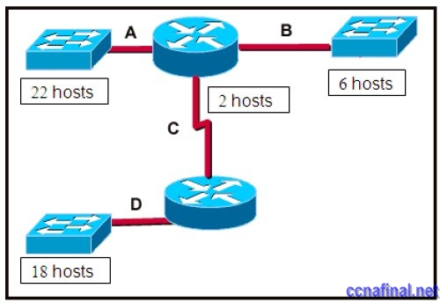
Refer to the exhibit. A network technician has been allocated the 192.168.1.0/24 private IP address range for use in the network that shown in the exhibit. Which subnet mask would be used to meet the host requirements for segment A of this internetwork?
255.255.255.128
255.255.255.192
255.255.255.224
255.255.255.240
255.255.255.248
18. Which subnet mask would be assigned to the network address of 192.168.32.0 to provide 254 useable host addresses per subnetwork?
255.255.0.0
255.255.255.0
255.255.254.0
255.255.248.0
19. What type of network cable is used between a terminal and a console port?
cross-over
straight-through
rollover
patch cable
20. Which option identifies the primary interface which would be used for initial configuration of a Cisco router?
AUX interface
Ethernet interface
serial interface
console interface
21. What are two common methods for setting a UTP Ethernet port to MDI or MDIX operation? (Choose two.)
cable color code association
cable selection and configuration
use of cable testers to determine pinouts
the automatic detection and negotiating of MDI/MDIX operation of the port
the enabling of the mechanism to electrically swap the transmit and receive pairs
22. Which device is used to create or divide broadcast domains?
hub
switch
bridge
router
repeater
23.
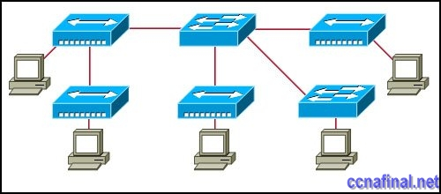
Refer to the exhibit. Assume that all devices are using default settings. How many subnets are required to address the topology that is shown?
1
3
4
5
7
24. What are three common methods for setting a UTP Ethernet port to MDI or MDIX operation? (Choose three.)
direct configuration of the device
cable color code association
cable selection and configuration
use of cable testers to determine pinouts
the enabling of the mechanism to electrically swap the transmit and receive pairs
the automatic detection and negotiating of MDI/MDIX operation of the port

Related Posts
- CCNA 1 Chapter 11 V4.0 Answers
- CCNA 1 Chapter 9 V4.0 Answers
- CCNA 1 Chapter 8 V4.0 Answers
- CCNA 1 Chapter 7 V4.0 Answers
- CCNA 1 Chapter 6 V4.0 Answers
- CCNA 1 Chapter 5 V4.0 Answers
- CCNA 1 Chapter 2 V4.0 Answers 100% updated 2011
- CCNA 1 Chapter 1 V4.0 Answers Updated 2011 100%
Tags: CCNA 1, ccna 1 2011, CCNA 1 Chapter 1, ccna 1 chapter 1 100%, ccna 1 chapter 1 2011, CCNA 1 Chapter 1 Answers, CCNA 1 Chapter 1 V4.0 Answers, ccna 1 module 1
← CCNA 4 Final Exam Answers (B) CCNA 1 Chapter 2 V4.0 Answers 100% updated 2011 →

Leave a Reply

